PROJECT WORK PHASE - I

Project Report

On

EYE CONTROLLED WHEEL CHAIR USING IMAGE PROCESSING TECHNIQUE
Submitted By

B.V.N. Sandhya 11189C025
C.Thanuja 11189C035
N.Likhita 11189C165

Guided By
Dr.M.Vinoth
Assistant Professor / ECE



Department of Electronics & Communication Engineering
Sri Chandrasekharendra Saraswathi Viswa Mahavidyalaya Enathur, Kanchipuram-631 561
November 2021

BONAFIDE CERTIFICATE
This is to certify that this report EYE CONTROLLED WHEEL CHAIR USING IMAGE PROCESSING TECHNIQUE is a bonafide work of B.V.N.Sandhya (11189C025), C.Thanuja (11189C035) and N.Likhita (11189C165) who carried out the project work phase  I under my supervision.

SIGNATURE SIGNATURE

Dr. M.Vinoth Prof..V. Swaminathan
Assistant Professor Head of the Department
Department of ECE Department of ECE

Submitted for the University Viva Voice Examination held on .
Place: Kanchipuram Date:

Internal Examiner External Examiner
ABSTRACT

According to the latest report prepared by the World Health Organization and the World Bank, 15 percent
(i.e. nearly 1 in 7 people on earth) of the world's population lives with some sort of disability. The use of
power driven wheelchairs with high navigational intelligence is a great step to integrate severely
handicapped people. Different systems are being developed, allowing the end-user to perform
safe movements and accomplish some daily life important tasks. The notion is to create an Eye
Monitored System that allows wheelchair navigation depending on the movement of the eyes. The p
roject outlines building a device where the patient sits in a wheelchair looking directly at the camera; can
move in a direction just by looking in that direction. The Robotic wheelchair uses the image processing
system to control the wheelchair. The user's eye movements are turned to a screen position using a
camera, without any direct contact. Through the use of measured gaze points, it is possible to translate
a desired movement into a physical one. This form of interface does not only provide a form of
transportation for those with severe disability but also allow the user to get a sense of control back into
their lives.

INTRODUCTION

LITERATURE SURVEY
ARDUINO boards are small electronic circuits including AT-mega microcontroller and other electronic components. There are different types of Arduino boards that their functionality are same, but their size, pin numbers and Microprocessor capabilities are different. The basic idea behind the Arduino comes from the fact that it is open-source and available to everyone interested in developing new projects. Arduino IDE (integrated development environment) is also very easy to install, use, and develop new sketches based on the integrated examples. Arduino boards also support different types of shields by which anyone interested in developing new and large projects could use it easily. Developed by 2005 from team Massimo Banzi, David Cuartielles, Tom Ingoe, Gianluca Martino and David Mellis in Italy, Arduino boards starting point was not education (Arduino, 2017). In electronics, especially for robotics system, the idea of DIY (do-it-yourself) developed rapidly with the introduction of Arduino. Later, researchers appreciated the freedom of Arduino boards and looked for new opportunities for their projects to create new ideas. Banzi (2008), as a co-founder of Arduino, published a book titled as Getting Started with Arduino. In his book, Banzi explained the Arduino as The Arduino philosophy is based on making designs rather than talking about them. It is a constant search for faster and more powerful ways to build better prototypes. We have explored many prototyping techniques and developed ways of thinking with our hands
The basic idea behind IoT is the network that connects physical devices (things) with Cloud technologies, Internet/web applications and network communications (Doukas, 2012). In this sense, IoT based devices allows users to access, store and retrieve data on the Internet and interact with other physical devices (Xia, Yang, Wang, & Vinel, 2012). Therefore, in order to create IoT based devices and applications, users need to use platforms allowing remote controls and data management systems. Doukas (2012) argues that Arduino boards are one of the suitable examples for IoT technologies. Arduino boards have IDE environment easy to understand and use, and micro-controllers allowing controlling different sensors and many Arduino shields. For this reason, the idea of open-source mentality of Arduino boards fits very well with IoT platforms, which Arduino boards offer simple, functional and extendable features for wired and wireless projects. In this regard, Al- Fuqaha, Guizani, Mohammadi, Aledhari, & Ayyash (2015), in their study, indicate that IoT elements include following components: identification, sensing, communication, computation, services, and semantic. The study clearly argued that Arduino (among other platforms such as TinyOS, Contiki, LiteOS, RiotOS) was one of the most common operating systems used in IoT environments. IoT based research in literature review mostly seems to focus on home control and monitoring systems. For example, Piyare (2013) presented a home control and monitoring system remotely using Arduino based technology. The study argued that IoT based system was feasible and effective in terms of controlling devices in home environment. Similarly, Soliman, Abiodun, Hamouda, Zhou, & Lung (2013) focused on creating smart home system in which home appliances and settings were controlled by IoT based technology. The study used embedding intelligence into sensors using Arduino board. Sundmaeker, Guillemin, Friess, & Woelfflé (2010), in their book, described Arduino as one of the specific IoT products that have indeed gained visibility recently. Barbon, Margolis, Palumbo, Raimondi, & Weldin (2016) presented an Arduino based IoT
system including service interface programming model in which provided support to network boards using different strategies. performance monitoring), banking (electronic checkbook, electronic credit card), security (personnel identification, automatic gates, surveillance) and medical (identification, patient history). Research clearly shows that Arduino boards play an important role in developing IoT based technologies. Arduino provides an open-source implementation of the code running on Arduino boards and in this way, users create flexible and functional wired or wireless projects according to their needs
A.K. Singh and Deepak Apte [002] have discussed a mathematical model forhysteresis in piezoelectric actuators based on domain wall bending and translation. Ahmad Gharib et. al. [004] have developed an analytical solution for analysis of functionally graded material (FGM) beams containing two layers of piezoelectric material, used as sensor and actuator.
Alberto Donoso and Jose Carlos Bellido [005] have dealt with finding the shape of distributed piezoelectric modal sensors for circular plates with polar symmetric boundary conditions. The problem is treated by an optimization approach, where a binary function is used to model the design variable: the polarization profile of the piezoelectric layer.
Amit Singh and Darryll J. Pines [007] have developed an integrated model of periodic 1-D structures with piezoelectric actuators for complete active/passive control. An analytical model is also developed to predict the performance of the periodic rods and beams with piezoelectric actuators acting as controllers. Andrew J. Fleming and S. O. Reza Moheimani [010] have introduced a frequency domain system identification technique aimed at obtaining spatially continuous models for a class of distributed parameter systems.
Dongchang Sun and Liyong Tong [021] have presented an equivalent model for smart beams with partially debonded piezoelectric actuator/sensor patches to analyze the effect of the actuator debonding on both open loop and closed loop behaviors.
Dongchang Sun et. al. [022] have investigated the effect of debonding on vibration control of beams with piezoelectric actuators and sensors. Collocated and non- collocated control schemes are used to study the effects of sensor or actuator debonding on active vibration control of smart beams.
Dr M. Collet and Dr M. Ouisse [023] have proposed a synthesis of new methodologies for developing a distributed, integrated shunted piezo composite for beams and plates applications able to modify the structural vibro-acoustical impedance of the passive supporting structure so as to absorb or reflect incidental power flow.
Dr. Chandrashekhar Bendigeri and Ritu Tomar [024] have presented the formulation of the finite element for static analysis based on isoparametric formulation. F.Ebrahimi, A.Rastgo [028] have presented the detailed mathematical derivations and numerical investigations performed for FG plates with two surface- bonded piezoelectric layers. The results are verified by those obtained from three- dimensional finite element analyses.
Fayaz R. Rofooei and Ali Nikkhoo [029] have derived the governing differential equation of motion for an un-damped thin rectangular plate with a number of bonded piezoelectric patches on its surface and arbitrary boundary conditions, by using Hamiltons principle. Gyuhae Park et. al. [034] have presented experimental investigations of vibration testing of an inflated, thin-film torus using smart materials.
Hui Zhang et. al. [038] have investigated, a theoretical model of radially polarized
piezo-electric ceramic tubes based on Timoshenko beam model. Based on the model, the particular attentions are devoted to effects of the boundary conditions at two ends on flexural resonance frequencies of the piezoelectric ceramic tubes.
J. Tang and K. W. Wang [043] have proposed to develop an active-passive hybrid vibration confinement system by using piezoelectric network actuators. A new simultaneous optimization / optimal eigenvector assignment approach is developed.

BLOCK DIAGRAM OF THE PROJECT

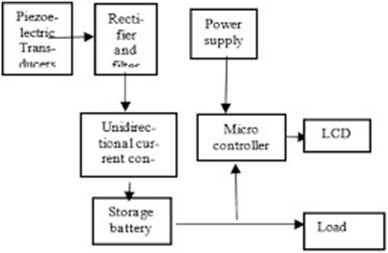

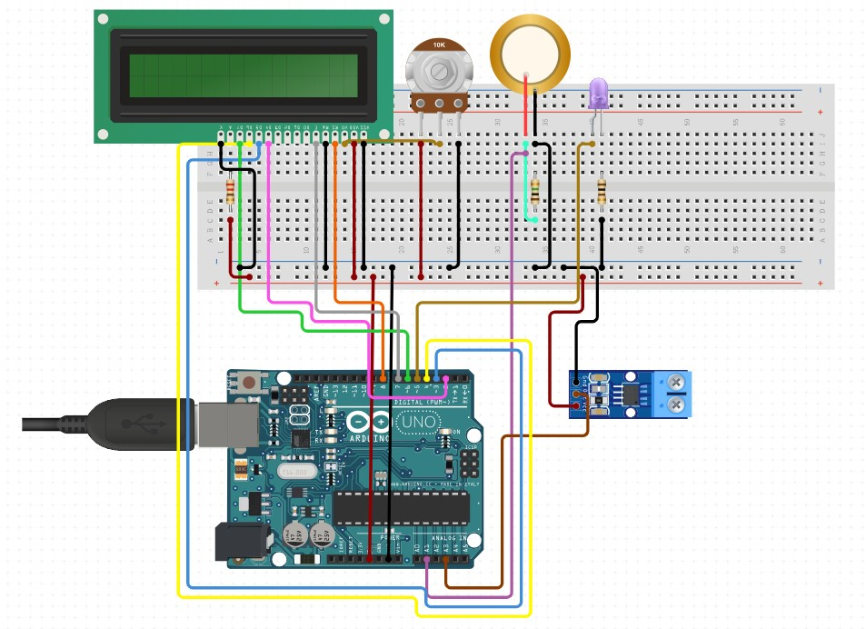
SCHEMATIC DIAGRAM OF THE PROJECT

Hardware Requirements of the Project Next Page
Software Requirements of the Project
Advantages of the Project Next Page
Disadvantages of the Project
Applications of the Project
List of References Next Page

Report may contain 10 pages approximately

